**RUSA Bill 15F21-[...]**

**Authors:** Evan M. Feldman, *Allocations Board Chair*

**Sponsors:** Allocations Board

**SPECIAL EVENTS FUNDING AUTHORIZATION ACT OF 2021**

***Whereas,*** the Rutgers University Student Assembly is charged with the duty of providing a means for and promoting student involvement and awareness within the University and the community at large; and

***Whereas,*** the mission of the RUSA Allocations Board is to promote and support diversity of programming made available to all Rutgers University Students through fair and efficient distribution of the Student Activity Fee; and

***Whereas,*** the RUSA Allocations Board is responsible for the allocation of Student Fee money to recognized Rutgers University student organizations through a variety of funding pathways; and

***Whereas,*** several student organizations require Special Allocation money to put on large-scale annual events due to high costs that can not be accommodated by the semesterly funding process; and

***Whereas,*** Special Events often receive security from RUPD due to the scale of their events, and the Allocations Board budgets to fund these security costs; and

***Whereas,*** as outlined in Art. III Sect. G of the RUSA Allocations Guidelines for Funding[1], the requirements for a special event call for meeting at least *three* of the four following criteria: 1. An annual event that has been funded for at least three of the past five years. 2. Must have at least one co-sponsorship from an academic or administrative department or outside company. This co-sponsorship must be equal to or greater than 20% of the proposed total cost of the event. 3. A total event cost of over $17,000.00 and accommodating a minimum of 250 people. 4. Co-sponsorship by seven or more campus groups; and

***Whereas,*** organizations were not penalized if their Special Event was not held between Spring 2020 and Spring 2021 due to cancellations resulting from the COVID-19 pandemic; and

***Whereas,*** the Special Events Funding Application for the 2021-2022 academic year opened on Monday, September 6th, 2021 at 12:00 AM, and were due on Monday, October 18th, 2021 at 11:59 PM; and

***Whereas,*** during the submission period, 16 applications were received in total; and

***Whereas,*** 5 of the 16 applications did not meet any of the Special Events requirements, and 2 of the 16 were second submissions by organizations with a qualifying Special Event, only 9 of the 16 applications were reviewed at the Special Events Hearing; and

***Whereas,*** organizations that did not qualify for Special Events Funding were notified by email and instructed how to receive funding for their event through the semesterly funding channel; and

***Whereas,*** the RUSA Allocations Board met on Monday, October 25th from 7:00 PM to 10:41 PM in Room 413 of the College Avenue Student Center to hear 9 Special Events presentations from the 9 qualifying student organizations and deliberate on final Special Events Funding; and

***Whereas,*** across the 9 Special Events a total of $250,275 was requested and, post-cuts, the Allocations Board funds $144,109 of these requests; and

***Whereas,*** in order to determine final funding numbers, the Allocations Board applied a 39% cut to all 9 clubs, and worked from that number to provide a 10% year-on-year increase to the 8 returning Special Events; and

***Whereas,*** the overall increase in Special Events funding provided from the 2020-2021 academic year to the 2021-2022 academic year is 23.8%, which was decided in light of the Student Activities Fee surplus due to COVID-19 related takebacks and increased student engagement since the return to campus; and

***Whereas,*** requested security costs amounted to $28,700 and $28,500 of these requests were funded without a cut; and

***Whereas,*** the RUSA Constitution requires the approval of the RUSA general body to approve Special Events funding; therefore

***Be it Hereby Enacted,*** that RUSA approves the 2021-2022 Special Events allocations for the registered student groups that are outlined in the attached spreadsheet, to the amount of $172,609.

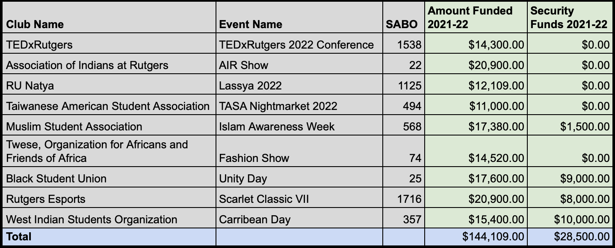

**Dates.**

## 

## Allocations Board Sponsorship

Introduced to the Allocations Board 27 October 2021

Passed by the Allocations Board 27 October 2021

Voted: Unanimous consent

## 

## Review by Executive Committee

Introduced to the Executive Committee 31 October 2021

Approved for floor by the Executive Board xx October 2021

## Floor of the Assembly

Introduced to the Assembly 04 November 2021

Passed by the Assembly xx November 2021

Voted: ## yays, ## nays, ## abstains, ## presents

1. [RUSA Allocations Funding Guidelines](https://rusa.rutgers.edu/sites/default/files/users/user9/RUSA_funding_guidelines.pdf): Please see Art. III Sect. G of Guidelines for Funding for more information on Special Events funding.